A new Tachistoscope version 1.4

We see three developments

- the Austrian approach with LC shutters and beamers
- the Swiss approach with two LCD screens and switching of the led backlights
- the Japanese approach with a high speed projector (1000 frames per second)

The technical developments are going so fast that tomorrow all the technical problems will be solved and payable.

When it comes to affordability the Swiss approach is the most promising. One need two LCD screens and a semipermeable mirror plus some electronic knowledge to steer the backlights. In the Swiss article this is all well documented.

The Austrian approach is a bit more costly: one needs two beamers (two times 200 to 1000 euros), and two LC shutters (two times 520 euros) then some mirrors and electronic knowledge to steer the LC shutters. The steering of the shutters is more difficult than the steering of the backlights in the Swiss approach. The backlights have low voltages so you can steer them with a microprocessor (E.g. an Arduino or Raspberry) The LC shutters need more high voltages 24 volts and the link to programming these shutters is more complicated. In the article there is some insight in the steering of the shutters but the design of the electronics is not to be found. So one has to find an electronical engineer to design the steering and in such a way that the steering can be influenced by a computer program.

I contacted the university of Tokyo about the high speed camera and high speed projector project but no reply so I don’t know whether this development is still going on or has stopped. Although it is a very promising development for future tachistoscope devices. A 2-D version of the projector would be a blessing.

So in the meantime we try to build our own tachistoscope.

I go for the Swiss approach plus a bit of the Austrian approach. In the Austrian approach the presented pictures are projected on a screen. In the Swiss approach one looks in a box with a semipermeable mirror, that’s a bit odd for a viewer so I will try to combine both elements of the approaches.

The second very important thing to me is that the device is programmable. One can write your own programs to use this device. And one can exchange programs and stimulus materials, so experiments can be repeated. No science without repetition. (repetitio mater studiorum est)

What do we need:

for a two way Tachistoscope we need
- two small LCD screens with good resolution and a controller. With the controller we can connect the LCD screen with the video output of a computer. These screens can be bought in China between 25 and 50 euros.
- two led lights with sufficient power (100 watt or more)
- two sets of Fresnel lenses
- two Triplet projection lenses
- a means to test the device

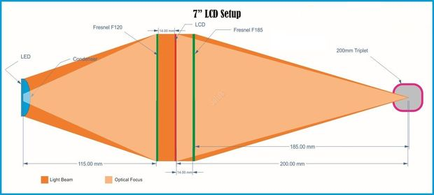

fig 1. schematic overview of a one channel projector
LCD screen preparation

The backlights of the LCD screens have to be removed and the light source has to be replaced by the power led light. By removing the backlights the LCD screen becomes a kind of a multiple-slide.

Leds

In order to get sufficient illumination for projection we need a powerful led.
In the world of leds the developments go fast. In China (Aliexpress) one can buy lots of different led lights. Leds lights can switch on and off very fast, for that reason we can use them to build a tachistoscope because we need milliseconds presentations.

We have to solve three problems with the high power leds:
- the on and off switching
- the synchronisation of the two led light sources
- the temperature

The “on” and “off” switching is easily done by a micro processor, but while the currents are high we cannot steer the Leds directly, there must be build in an electronic switch to make things happen. This switch is called a mosfet.
For microcontrollers there are mosfet boards for sale, but not all mosfets are usefull for our approach: we need a mosfet that switches on the pulse(directly) e.g. a Solid State Relais (e.g. a Crydom SSR D2D12). There are two types of SSR: DC-AC and DC-DC. The DC-DC type switches on the pulse and the DC-AC type switches on the zero phase, this last type gives a light switching delay. In our approach we need a DC-DC type.

Schematically it looks like this:

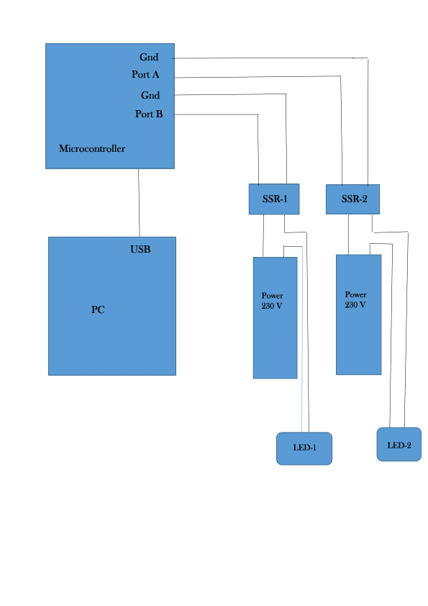
fig 3. Schematic setup of SSR and microprocessor
The synchronisation

while both leds are steered by the same microprocessor the synchronisation is okay, the SSR’s and the two leds are acting on the same clock.

Temperature

Many people make their own beamers in this way because they are cheaper. The problem with continuous illumination is that the high power leds are switched on all the time so they must be cooled down.

In our approach where the switched on-times are between 1 and 200 milliseconds (max) I hope to avoid active cooling (noise reduction).

Fresnel lenses

are used to give the light beam an optical focus
One can buy them in India, China and America
Prices are varying because of transfer/shipping rates.
around 10 euros a piece

Triplet projection lenses

also India, China, America
around 40 dollars a piece

Problem with the lenses is the focal ratio(f) what ratio can we use or better how can we calculate these ratio’s e.g. starting with a 7 inch lcd screen?
Without this knowledge one orients on existing projects.
Perhaps it is simple?

We adjusted fig 1 as follows:
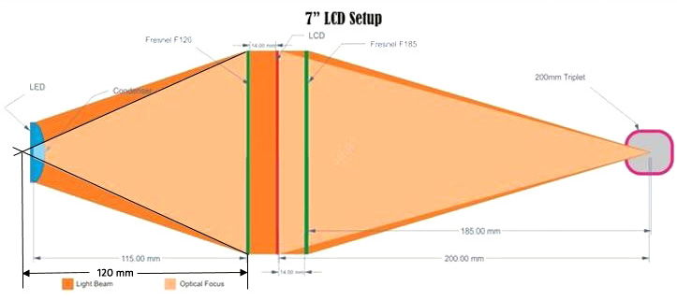

fig 4. Adjusted fig 1. with focal point of the LED light

we added the focal point of the led light on the left side of the above picture and what do we see now?
The distance from focal point of the led light to the Fresnel lens is 120 mm
and is exactly the value of the needed Fersnel f= 120 mm.
To the right we see the distance from focal point of the projection lens to the Fresnel lens is 185 mm and corresponds with the needed Fresnel lens f=185 mm.
The distance between focal point of the projection lens and the LCD screen in the above example is 200 mm and corresponds with the value of the projection lens we need in this example f=200 mm

Programmability
I stressed the point that the device has to be programmable.
Why is that?
A device that is programmable is more accessible, it becomes a multi purpose device.
It has also to do with what science is supposed to be: that is in my opinion that ideas can be tested and research can be repeated. A single publication with some research results have in fact little scientific value.
This becomes different when others confirm the results.
Results become more reliable and ideas more valid.
When a device is programmable the device includes the hardware and the software. When software and stimulus materials can be exchanged research can be repeated easily.
In the future we need, besides ideas and research results, open software, open hardware, open electronics and open stimulus materials.

Testing the device

We cannot take for granted that what we put in the device will come out, so we have to test the device on its reliability. How do we do that?
Replace the projection lens with a photoelectric cell.
Connect the output to a microprocessor (e.g. Arduino with pulsIn() command)
Program the device as follows
e.g. present a white picture for 100 milliseconds then 2000 milliseconds pause and then again, and so on.
Check the output of the microprocessor: is there a signal that measures also 100 milliseconds?
Change the presentation time and measure again.

Jan Sterenborg, psychologist and researcher

For the three aproaches look in the technical literature on the website www.ipd-community.nl
IPD website under reliability of the tachistoscope

